**Department of Computer Science and Engineering**

**University of Liberal Arts Bangladesh**

**Quiz 2 (Summer 2020)**

**Course: Software Engineering (CSE 404)**

**Section: 1 --- Duration: 1 Hour**

**______________________________________________________________________________________**

**PLEASE ANSWER ALL QUESTIONS. Total 10 Marks**

**QUESTION 1**

What are the SOLID principles of Object-Oriented design?

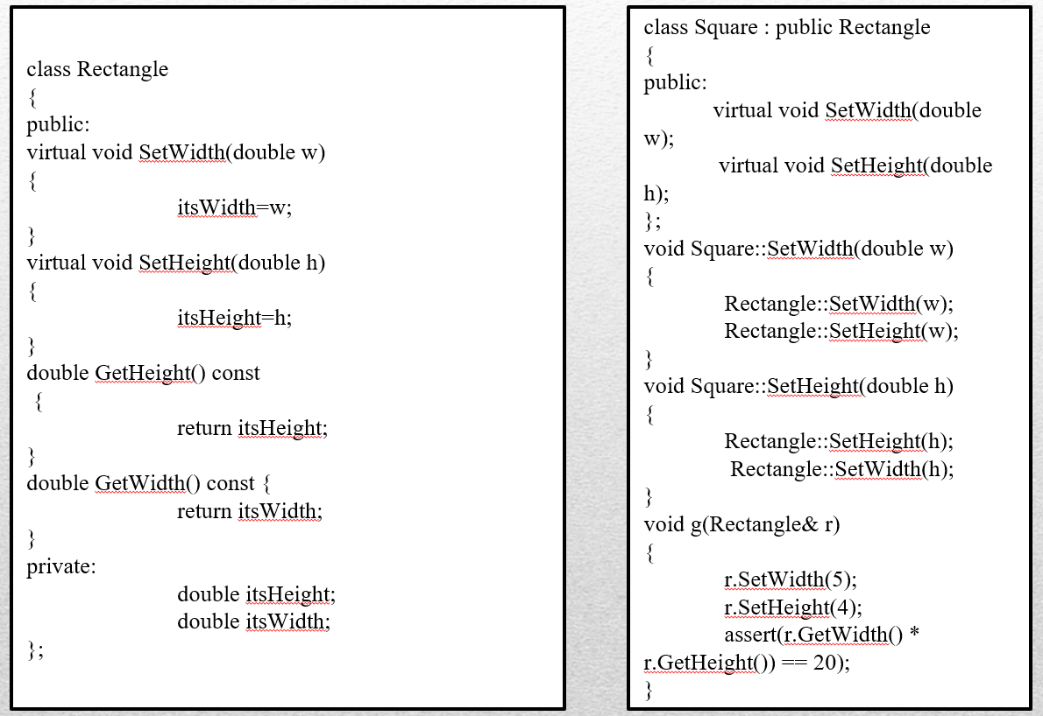

Consider the classes given above. Does this design maintain Liskov substitution principle (LSP)? Explain your answer. **(2+3=5 Marks)**

**QUESTION 2**

You have been assigned the job of engineering new word-processing software (similar to MSWord/ LibreOffice). A class named ***document*** is identified. Define the attributes and operations that are relevant for ***document***. **(2+3=5 Marks)**

**\*\*END OF QUESTIONS\*\***